Trignometric Method:

The following equation defines an ellipse trigonometrically as shown in fig:

x = a * cos (θ) +h and  
y = b * sin (θ)+k  
where (x, y) = the current coordinates  
a = length of major axis  
b = length of minor axis  
θ= current angle  
(h, k) = ellipse center

In this method, the value of θ is varied from 0 to Trignometric Method radians. The remaining points are found by symmetry.

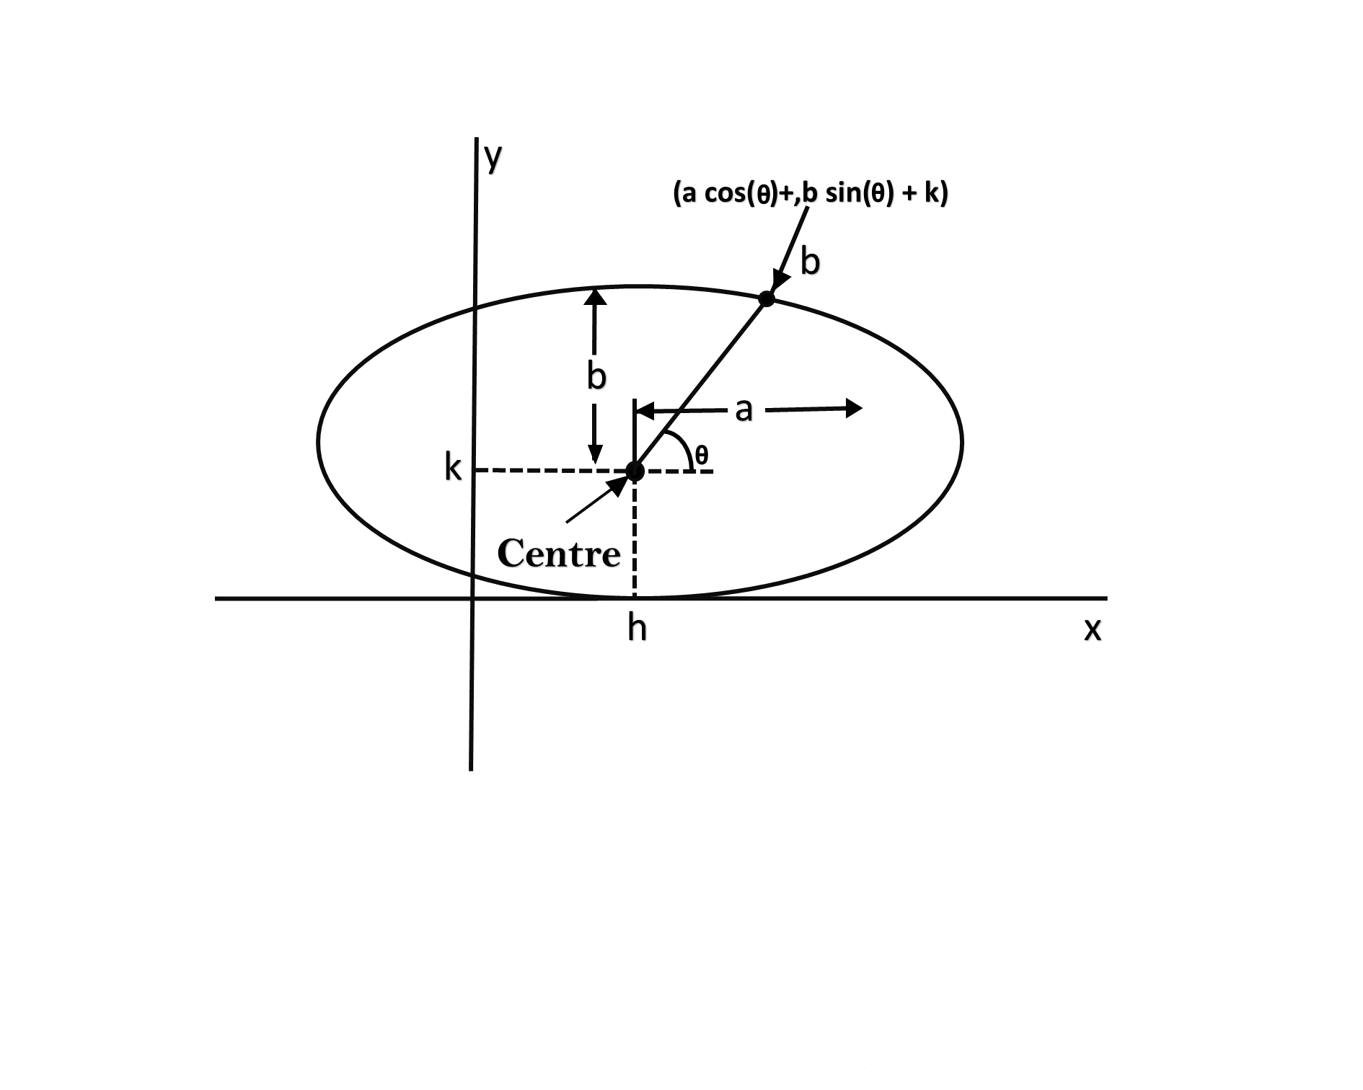

Drawback:

1. This is an inefficient method.
2. It is not an interactive method for generating ellipse.
3. The table is required to see the trigonometric value.
4. Memory is required to store the value of θ.

Algorithm:

**Step1:** Start Algorithm

**Step2:** Declare variable x1,y1,aa1,bb1,aa2,bb2,fx,fy,p1,a1,b1

**Step3:** Initialize x1=0 and y1=b/* values of starting point of circle */

**Step4:** Calculate aa1=a1*a1  
          Calculate bb1=b1* b1  
          Calculate aa2=aa1*2  
          Calculate bb2=bb1*2

**Step5:** Initialize fx = 0

**Step6:** Initialize fy = aa_2* b1

**Step7:** Calculate the value of p1and round if it is integer  
          p1=bb1-aa1* b1+0.25* aa1/

**Step8:**

While (fx < fy)

{

Set pixel (x1,y1)

Increment x i.e., x = x + 1

Calculate fx = fx + bb2

If (p1 < 0)

Calculate p1 = p1 + fx + bb1/

else

{

Decrement y i.e., y = y-1

Calculate fy = fy - 992;

p1=p1 + fx + bb1-fy

}

}

**Step9:** Setpixel (x1,y1)

**Step10:** Calculate p1=bb1 (x+.5)(x+.5)+aa(y-1)(y-1)-aa1*bb1

**Step 11:**

While (y1>0)

{

Decrement y i.e., y = y-1

fy=fx-aa2/

if (p1>=0)

p1=p1 - fx + aa1/

else

{

Increment x i.e., x = x + 1

fx= fx+bb_2

p1=p1+fx-fy-aa1

}

}

Set pixel (x1,y1)

**Step12:** Stop Algorithm

Program to draw a circle using Trigonometric method:

1. #include <graphics.h>
2. #include <stdlib.h>
3. #include <math.h>
4. #include <stdio.h>
5. #include <conio.h>
6. #include <iostream.h>
7. # define pi 3.14
9. **class** bresen
10. {
11. **float** a, b, h, k, thetaend,step,x,y;
12. **int** i;
13. **public**:
14. **void** get ();
15. **void** cal ();
16. };
17. **void** main ()
18. {
19. bresen b;
20. b.get ();
21. b.cal ();
22. getch ();
23. }
24. **void** bresen :: get ()
25. {
26. cout<<"\n ENTER CENTER OF ELLIPSE";
27. cin>>h>>k;
28. cout<<"\n ENTER LENGTH OF MAJOR AND MINOR AXIS";
29. cin>>a>>b;
30. cout<<"\n ENTER STEP SIZE";
31. cin>> step;
32. }
33. **void** bresen ::cal ()
34. {
35. /* request auto detection */
36. **int** gdriver = DETECT,gmode, errorcode;
37. **int** midx, midy, i;
38. /* initialize graphics and local variables */
39. initgraph (&gdriver, &gmode, " ");
40. /* read result of initialization */
41. errorcode = graphresult ();
42. **if** (errorcode ! = grOK)    /*an error occurred */
43. {
44. printf("Graphics error: %s \n", grapherrormsg (errorcode);
45. printf ("Press any key to halt:");
46. getch ();
47. exit (1); /* terminate with an error code */
48. }
49. theta= 0;
50. thetaend=(pi*90)/180;
51. whilex (theta<thetaend)
52. {
53. x = a * cos (theta);
54. y = b * sin (theta);
55. putpixel (x+h, y+k, RED);
56. putpixel (-x+h, y+k, RED);
57. putpixel (-x+h, -y+k, RED);
58. putpixel (x+h, -y+k, RED);
59. theta+=step;
60. }
61. getch();
62. }

**Output:**

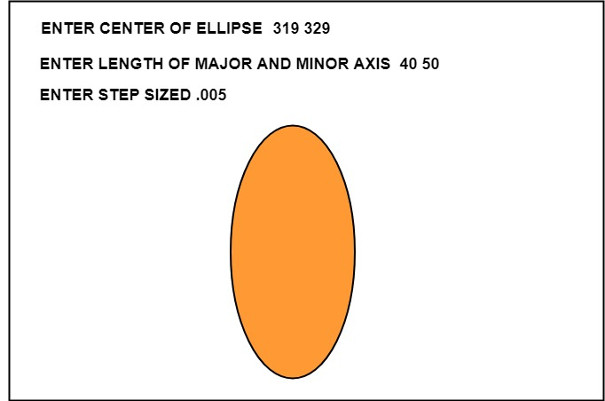

Ellipse Axis Rotation:

Since the ellipse shows four-way symmetry, it can easily be rotated. The new equation is found by trading a and b, the values which describe the major and minor axes. When the polynomial method is used, the equations used to describe the ellipse become

Trignometric Method

where (h, k) = ellipse center  
a = length of the major axis  
b = length of the minor axis  
In the trigonometric method, the equations are  
x = b cos (θ)+h       and       y=a sin(θ)+k

Where (x, y) = current coordinates  
a = length of the major axis  
b = length of the minor axis  
θ = current angle  
(h, k) = ellipse center

Assume that you would like to rotate the ellipse through an angle other than 90 degrees. The rotation of the ellipse may be accomplished by rotating the x &y axis α degrees.

          x = a cos (0) - b sin (0+ ∞) + h y= b (sin 0) + a cos (0+∞) + k

